March Profile Principal’s Report

Profile School is one of nine New Hampshire High Schools receiving recognition for having a standalone requirement for a personal finance course in order to graduate. The award letter read in part, “**We spotlighted *Profile Junior - Senior High School* in our recent Survey of New Hampshire High Schools which reviewed the program of studies for all Granite State high schools to identify the extent of financial literacy education in New Hampshire.”** Superintendent Couture and I will be attending the Executive Council meeting on March 21st to receive the award from the Governor.

Profile Winter Carnival 2018 started Monday February 19 and culminated with a dance on the evening of February 23. The students were engaged and excited during the events and through the combined efforts of the Profile faculty, staff, and student population, a sense of Patriot pride and community was fostered and developed.

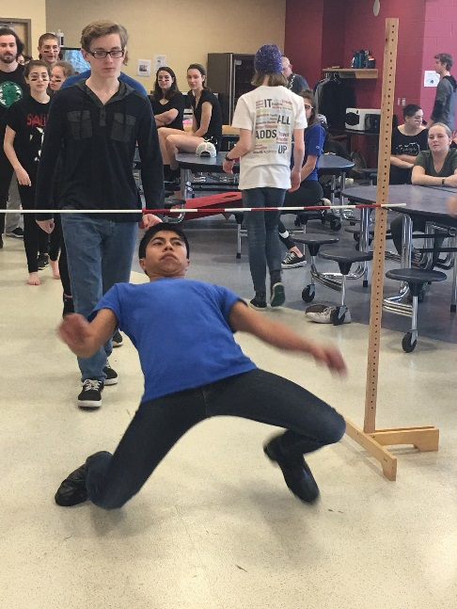 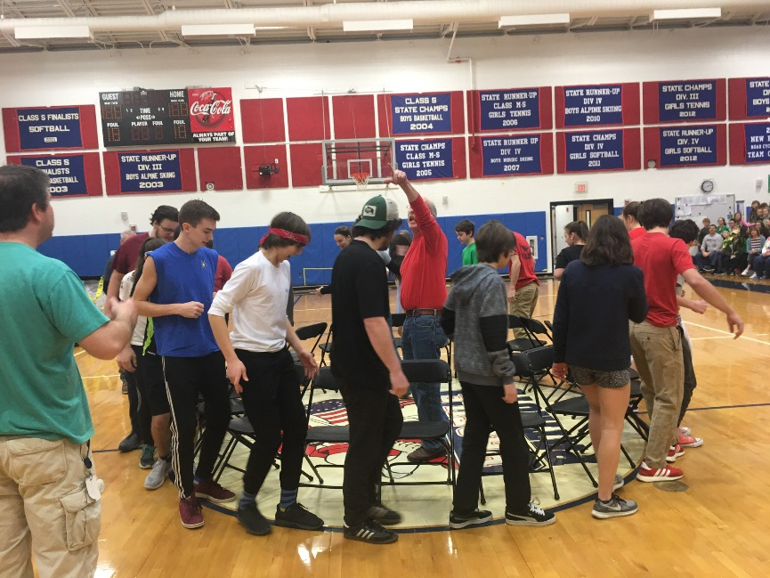

Five Profile students received Honorable Mentions in the annual Scholastic Art and Writing awards through the National Writing Project. A description of the program is as follows:

Each year, the Alliance partners with more than 100 [visual arts and literary arts organizations](http://www.artandwriting.org/who-we-are/regionalprograms/) across the country to bring the Scholastic Awards to local communities. Teens in grades 7–12 apply in 29 [categories](http://www.artandwriting.org/what-we-do/the-awards/categories/) of art and writing. In 2018, students submitted nearly 350,000 works of art and writing to the Scholastic Awards.

Submissions are juried by [luminaries in the visual and literary arts](http://www.artandwriting.org/who-we-are/jurors/), some of whom are past award recipients. Panelists look for works that best exemplify originality, technical skill, and the emergence of a personal voice or vision.

This year’s recipients are; Adam Bell, Sophie Bell, Emerson Jette, Thomas Oliver, and Zachary Stanley.

**Follow-up Items:**

* Honor Roll has been posted online as well as in the main corridor at school.
  + Students receiving “highest honors” were once again awarded an outing with the Principal to the lunch destination of their choice.
    - The Profile administrative team continues to work in conjunction with Guidance to find a method of recognition for the achievements of students in the CTE program.
* Entryway lock, intercom, and security camera upgrades are scheduled for April vacation
* LED project paperwork is in process and we’re waiting to schedule an initial meeting

**Upcoming Events:**

* 3/21 SATs at Profile
* 3/22 Commissioner Visit
* 3/23 End of Third Quarter
* 4/6 College Access Convention