FOR IMMEDIATE RELEASE

A Community Discussion on Mental Health Awareness Comes to schools in SAU 35.

May 2, 2018 – Half of all mental illness in Americans emerges by the age of 14. One in five children between the ages of 13-18 has, or will have, a serious mental illness. Those statistics point out the critical need for families to know the “five signs of mental illness” and be empowered to discuss the issue in their home.
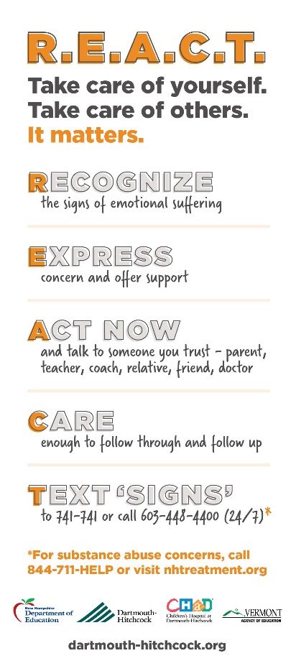
In spite of its impact on our society, mental illness remains an issue that is difficult to discuss. To help facilitate a conversation, SAU 35 in cooperation with Dartmouth-Hitchcock Health, will host Dartmouth-Hitchcock Senior Director of Public Affairs John Broderick for a discussion about mental health awareness on May 2nd at the Lisbon Regional School at 9:45 AM and The Profile School in Bethlehem at 1pm. This event is free and open to the public.
Dartmouth-Hitchcock and the New Hampshire Department of Education joined together to create REACT, an awareness campaign that provides adults, teachers and students throughout New Hampshire and Vermont with tips, resources and support to deal with the five signs of emotional suffering: agitation, personality change, poor self-care, withdrawal and hopelessness. REACT is an acronym to Recognize the signs, Express concern, Act now and talk to someone you trust, Care enough to follow through and follow up, and Text “signs” to 741-741.
REACT focuses attention on changing the stigma of mental illness. Broderick, a former N.H. Supreme Court Chief Justice, was seriously injured in 2002 when he was attacked by his son, who at the time suffered from an undiagnosed mental illness. He has been speaking to high school and college students, crisscrossing the state of New Hampshire for almost two years. First, as state chair of Change Direction, a national organization dedicated to changing the stigma of mental health in America; and now on behalf of Dartmouth-Hitchcock, he is asking parents and students to REACT, so those in need receive the care and support they deserve.
Broderick hopes telling his story will help others feel comfortable talking about mental illness and says “It’s the most rewarding work I have done in my professional life and may be the most important work I have ever done.”
###

