December Principal’s Report

On December 2 a group of six Profile STEM students accompanied Mr. Briere and Bill Church to the University of Vermont to compete in the Aiken Engineering Challenge. The Aiken Engineering Challenge is a program supported by the University of Vermont George D. Aiken Lectures that aims to involve young Vermont and Northern New Hampshire students in engineering and technology; a topic that long interested Senator Aiken. This year’s challenge was the following:

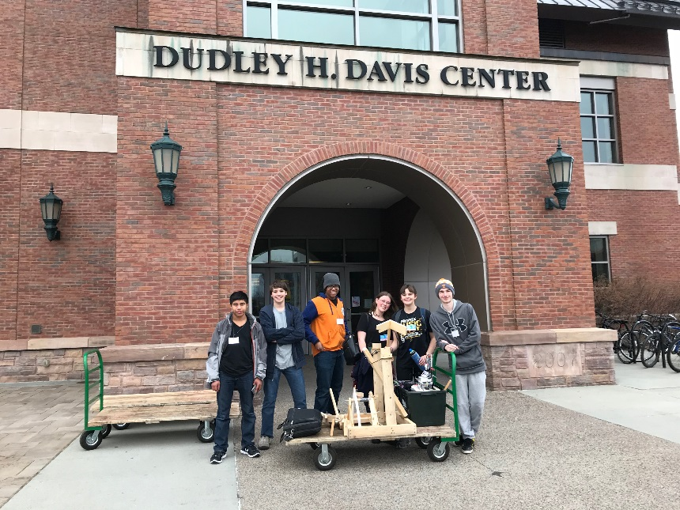
This year we are taking on a classic challenge in a new way, launching ping-pong balls into targets! The targets will be randomly selected, from a set of 5 "easy" targets and 4 "hard" targets. This selection will occur 5 minutes prior to teams setting up on a field and will vary in both difficulty and strategy required to score. Students will then be able to decide on their game plan, including the desired distance for each of these targets. Go too far and risk missing too many targets; go too short and risk each successful shot not being worth enough points.
Profile’s winter sports teams are up and running. With new snow blanketing the area, the Nordic team has been able to travel to Bretton Woods to begin their outdoor training regimen. The Alpine ski team has been training at Cannon Mountain for the past several weeks and will begin competing after the holiday break. The varsity basketball teams have already had games and are working hard to have a successful season. All middle school athletes are working hard in their respective sports. We are looking forward to a strong showing this winter.
We have tentatively been awarded the school safety grant to upgrade our security cameras and entryway access. The state has decided the grant will be an 80/20 funding split. The total cost of the proposed project as voted on last month is $12,500. The state will reimburse the district $10,000 of the total amount. Once final approval is received from the Governor’s Office we will schedule the work to be completed, tentatively over February break.
IMPACCT is a partnership of New Hampshire Vocational Rehabilitation (NHVR), Granite State Independent Living (GSIL), and high schools throughout New Hampshire. The program is dedicated to helping students with disabilities become part of the local workforce as they navigate from high school to employment, post-secondary education, or training that leads towards a career. For the next 5-6 weeks during X-Block on Tuesdays, we have three Profile students participating in IMPACCT workshops. These workshops include adult led activities through Granite State Independent Living and NH Vocational Rehabilitation that focus on pre-employment transition skills. Students who participate will learn self-advocacy and soft skills training and that will transfer to work skills. In addition, they have the opportunity to earn an elective credit. We are excited to be working with IMPACCT and look forward to offering more opportunities for students to participate in the future.

Follow-up Items:
- We have formalized the tracking of mileage and trip information for the small bus.
- The Budget Committee has met and copies of the budget have been sent to the board.
- Steering Committee will have initial meeting set up for January.

Upcoming Events:
- 12/25-1/1 Holiday Break
- 1/15 Civil Rights Day – No School
- 1/18 Winter Concert

