April Profile Principal’s Report
On March 15, dedicated parents and the Booster Club provided all Profile staff members with a wonderful appreciation luncheon. The staff were treated like movie stars, given gift bags and scrumptious sandwiches. After the luncheon the staff attended a two hour workshop with Ashley Moriarty, from Kingdom Autism, whereby faculty and staff received training pertaining to a greater understanding of autistic students. Ashley covered topics ranging from identification to differentiation within teacher’s classrooms. The workshop was well received by the staff and was attended by parents and community members .
Shea Young has been chosen to represent New Hampshire in the 44th annual Lions Twin State Soccer game on July 21, 2018. Shea and his teammates from New Hampshire will compete against an equally talented team from Vermont. In addition to being proud of Shea’s accomplishments, Profile School is also proud that our varsity boy’s head coach Brent Detamore has been named as the New Hampshire team’s head coach.
Education Commissioner Frank Edelblut toured all of the SAU 35 schools on Thursday March 22. He was at Profile for lunch and visited several middle and high school classrooms. Commissioner Edelblut engaged with students and staff as he toured the building, even stopping to judge a cookie baking competition in the Family and Consumer Science kitchen.
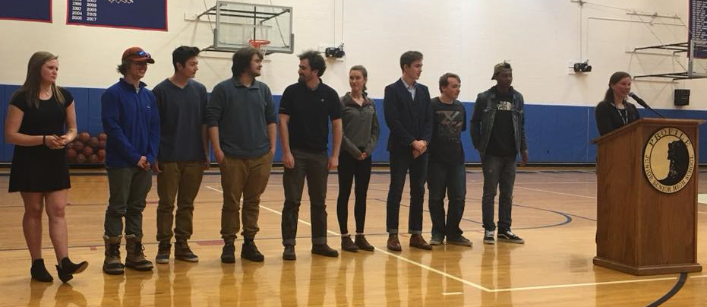
On Friday March 23 as part of their Senior Speech class, nine seniors gave individual speeches to a nicely sized audience comprised of parents, staff, and students. The topic was “Graduation Speeches” and all of the students did a fantastic job. Congratulations to Mrs. Innes and her class on a job well done.

Follow-up Items:
- LED project initial meeting went well, the project will start in June after school is out
- Middle School window project will be discussed in May

Upcoming Events:
- 4/10 SATs at Profile (Make-up)
- 4/14 ACTs at Profile
- 4/23-4/27 April Break
- 5/3-5/17 State Testing
- 5/7-5/18 AP Exams
- 5/17 Spring Arts Festival

